COGNIZANT WEEK 4
BHUMISTHA SAHOO

Exercise 1: Setting Up JUnit

Maven pom.xml Configuration

```xml
<?xml version="1.0" encoding="UTF-8"?>
<project xmlns="http://maven.apache.org/POM/4.0.0"
xmlns:xsi="http://www.w3.org/2001/XMLSchema-instance"
xsi:schemaLocation="http://maven.apache.org/POM/4.0.0
http://maven.apache.org/xsd/maven-4.0.0.xsd">
<modelVersion>4.0.0</modelVersion>

<groupId>com.example</groupId>
<artifactId>junit-demo</artifactId>
<version>1.0-SNAPSHOT</version>

<properties>
<maven.compiler.source>11</maven.compiler.source>
<maven.compiler.target>11</maven.compiler.target>
<project.build.sourceEncoding>UTF-8</project.build.sourceEncoding>
</properties>

<dependencies>
<!-- JUnit 4 Dependency -->
<dependency>
<groupId>junit</groupId>
<artifactId>junit</artifactId>
<version>4.13.2</version>
<scope>test</scope>
</dependency>
</dependencies>
</project>
```

---

Calculator Class (Source Code)

**File:** `src/main/java/com/example/Calculator.java`

```java
package com.example;

public class Calculator {

public int add(int a, int b) {
return a + b;
}

public int subtract(int a, int b) {
return a - b;
}

public int multiply(int a, int b) {
return a * b;
}

public int divide(int a, int b) {
if (b == 0) {
throw new IllegalArgumentException("Cannot divide by zero");
}
return a / b;
}
}
```

---

### Calculator Test Class

**File:** `src/test/java/com/example/CalculatorTest.java`

```java
package com.example;

import org.junit.Test;
import org.junit.Before;
import org.junit.After;
import org.junit.Assert;

public class CalculatorTest {

private Calculator calculator;

// Runs before each test
@Before
public void setUp() {
calculator = new Calculator();
System.out.println("Setting up calculator for test");
}

// Runs after each test
@After
public void tearDown() {
calculator = null;
System.out.println("Cleaning up after test");
}

@Test
public void testAdd() {
int result = calculator.add(5, 3);
Assert.assertEquals("5 + 3 should equal 8", 8, result);
}

@Test
public void testSubtract() {
int result = calculator.subtract(10, 4);
Assert.assertEquals("10 - 4 should equal 6", 6, result);
}

@Test
public void testMultiply() {
int result = calculator.multiply(4, 5);
Assert.assertEquals("4 * 5 should equal 20", 20, result);
}

@Test
public void testDivide() {
int result = calculator.divide(10, 2);
Assert.assertEquals("10 / 2 should equal 5", 5, result);
}

@Test(expected = IllegalArgumentException.class)
public void testDivideByZero() {
calculator.divide(10, 0);
}
}
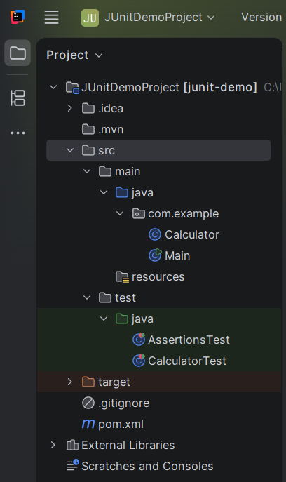

Output
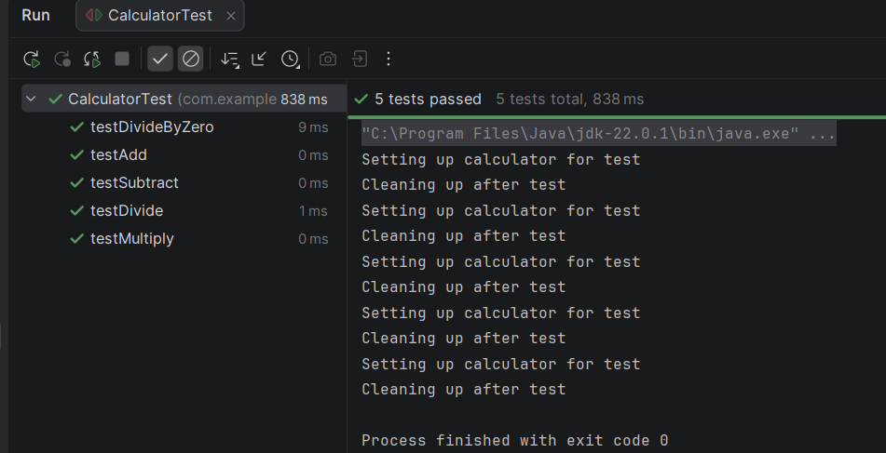
Exercise 3: Assertions in JUnit

Assertions Test Class

**File:** `src/test/java/com/AssertionsTest.java`

```java
package com.example;

import org.junit.Test;

import static org.junit.Assert.*;

public class AssertionsTest {

@Test
public void testAssertions() {

// Assert Equals
assertEquals(5, 2 + 3);

// Assert True
assertTrue(5 > 3);

// Assert False
assertFalse(5 < 3);

// Assert Null
assertNull(null);

// Assert Not Null
assertNotNull(new Object());
}
}

Assertion Types Reference

| Assertion | Description | Example |
|-----------|-------------|---------|
| assertEquals() | Checks if two values are equal | `assertEquals(5, 2+3)` |
| assertTrue() | Checks if condition is true | `assertTrue(5 > 3)` |
| assertFalse() | Checks if condition is false | `assertFalse(5 < 3)` |
| assertNull() | Checks if object is null | `assertNull(null)` |
| assertNotNull() | Checks if object is not null | `assertNotNull(new Object())` |

---

Output
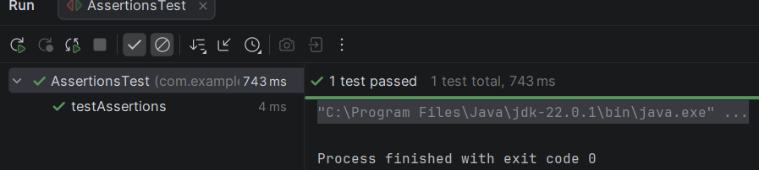

Project Structure

```
JUnitDemoProject/
├── pom.xml
├── src/
│ ├── main/
│ │ ── java/
│ │ └── com/
│ │ └── example/
│ │ └── Calculator.java
│ └── test/
│ └── java/
│ └── com/
│ ├── CalculatorTest.java
│ └── AssertionsTest.java

-

